**VB .NET** V/S **C#:**

VB .NET C#

* VB.NET has a English-like syntax C# has a syntax similar to C and C++
* EX: you use the "End If" statement you use a closing brace "}.

to close an if block,

* VB.NET, on the other hand, is

case-**insensitive** by default, although

you can enable case sensitivity with

the "Option Compare Binary" statement. C# is case-sensitive

* In VB.NET, variables are initialized to in C#, you need to explicitly initialize variables before using them their default values automatically

**ASP .NET:**

**What is ASP.NET?**

**ASP .NET is the server side technology used for developing dynamic websites and web applications like twitter,facebook etc**

**It runs in CLR- common language runtime**

.NET is a developer platform made up of tools, programming languages, and libraries for building many different types of applications.

**ASP.NET extends the**[**.NET developer platform**](https://dotnet.microsoft.com/en-us/learn/dotnet/what-is-dotnet)**with tools and libraries specifically for building web apps.**

ASP.NET is a web development framework that allows developers to build dynamic web applications and services. It provides a variety of tools, libraries, and frameworks for creating web-based applications, including web forms, MVC (Model-View-Controller), and Web API.

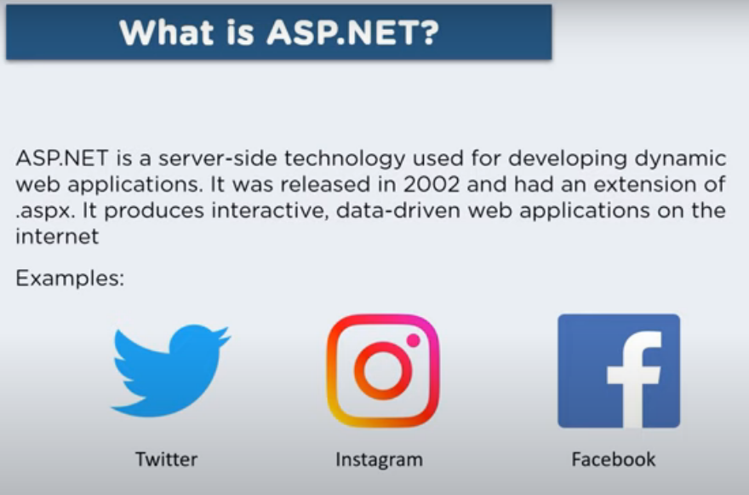

**ASP .NET Architecture:**

1. ASP .NET requests HTML file from the server
2. Internet Information services (IIS) passes that information to ASP .NET engine
3. ASP .NET engine reads the file and executes the scripts.
4. IIS is an instance able web server uses to host ASP .NET web apps
5. Then ASP .NET returns to the browser as Html

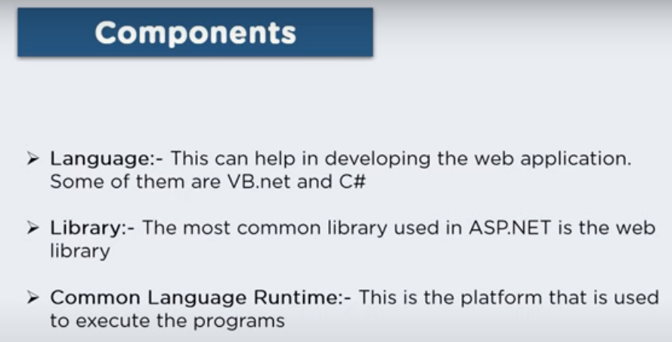

**Applications developed in ASP .NET performs better than other app developed in node JS and PHP**

The .NET runtime is separate from both MSBuild and VS Build.

The .NET runtime is the execution environment for running .NET applications. It includes the Common Language Runtime (CLR), which provides services such as memory management, exception handling, and security. The runtime also includes the .NET Framework Class Library (FCL) or the newer .NET Core Libraries, which provide a vast collection of pre-built classes and APIs for developing applications.